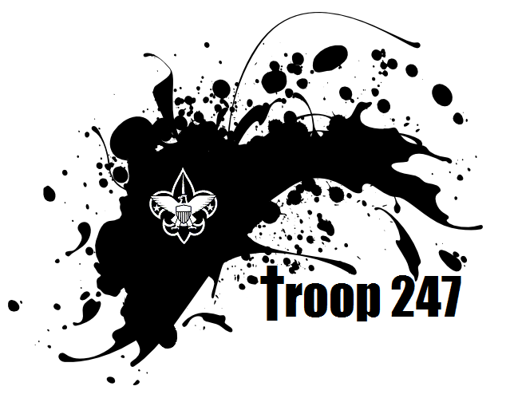
Please keep this half for your information

Campout Location: ___________________________________
___________________________________
___________________________________
Leaving on _______ at __________ from__________________
Will Return on ________ at about _________ to ___________________
Leader in Charge is ____________________________
In case of emergency call leader ___________________________
Cost of this Campout per boy/leader/parent ________________
Please refer to Chapter 9 (pages 286-311) of the Scout Handbook for information on camping, feel free to ask questions of Adult and Boy Leadership
Troop 247 is not responsible for lost or damaged personal items, please keep this in mind with costly electronic items (ie. Cell Phones, MP3 Player, iPods, Cameras, etc)

As the parent or legal guardian of _______________________, I give permission for him to participate in this outing with Troop 247.

Activity ___________________________________Dates ______________________________
Cost ____________________ Form of Payment ______ Scout Account OR _______Cash/Check

Understanding that things that Scouts do contain some risk for injury I agree to hold the Troop 247, its leaders, property owners, Scouts in attendance, and parents attending blameless for any accidents or injury that may occur during this outing except for clear acts of negligence or non-adherence to policies of the Boy Scouts of America.

I also give permission to the Leaders or Scouts of Troop 247 to render First Aid or in the event of emergency to any Physician chosen by the Leaders of Troop 247 to treat, hospitalize, provide anesthesia, surgical procedures, give medications, or any other medical treatment if the need arises.

I also give permission to the Adult Leaders to administer medications provided and discussed prior to leaving for this event. Medication times will be followed to the best of our ability but I understand that that medication administration may be given early, late, or missed due to the nature of Scouting activities, discretion of the Leaders, or refusal of your child.

In case of emergency, I can be reached by phone at ______________________ or _____________________________________

If I cannot be reached, please contact ___________________ at ____________________

We agree to follow the Scout Law, Oath, and Leader direction at this activity and in case of violation may be asked to leave early.

Signed _____________________________ (scout)
Signed _____________________________ (parent) Date : __________________

